Project: <https://github.com/AZANIR/cypressAllure>

GitHub

Comments:

1. Change "Username" and "Password".

It is not clear how to change "Username" and "Password".

2. Version of node.js and JSON.

Node.js and JSON version not specified.

3. Clean code.

Commented code in cypress\e2e\tests\myAccount.test.ts file.

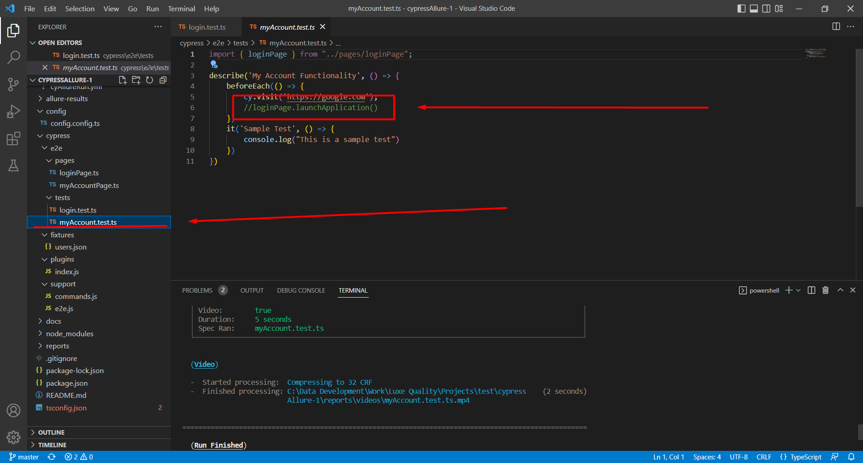

Errors:

1. Error: Process completed with exit code 1.

The test “login with wrong email format credentials read data from fixture” is failed.

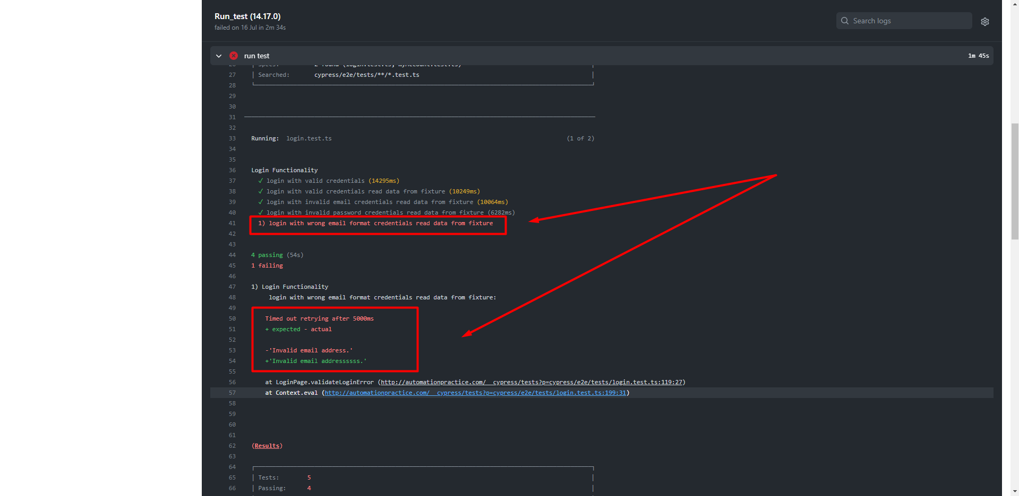

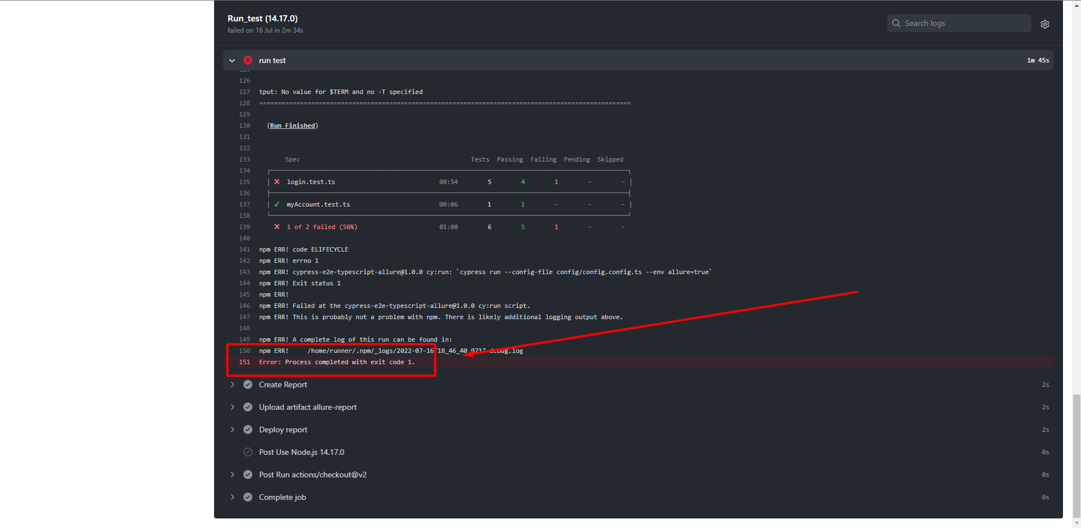

2. JSON schema for the TypeScript compiler's configuration file.

Cannot find type definition file for 'cypress'.

